SLI0133, KLE0207

POS PROJEKT

2024

**Zadání**

|  |  |
| --- | --- |
| **Firma:** | ahwee |
| **Číslo topologie:** | B |
| **Čísla VLAN:** | VLAN A=13, VLAN B=30, VLAN C=47 |
| **Počty stanic na segmentech:** | VLAN A=341, VLAN B=225, VLAN C=22, Segment S1=362 |
| **Rozsah veřejných adres:** | 174.96.64.0/19 |
| **Rozsah privátních adres:** | 10.75.76.160/27 |
| **Rozsah IPv6 adres:** | 2001:865c:a921::/48 |
| **Zvláštní segmenty** | NAT: VLAN C, DNS: VLAN A (PCA), DHCP: Segment S1, T: VLAN B, N: VLAN A |
| **NAT pool:** | 17 |
| **Směrovací protokol:** | RIP |

**Schéma topologie B**

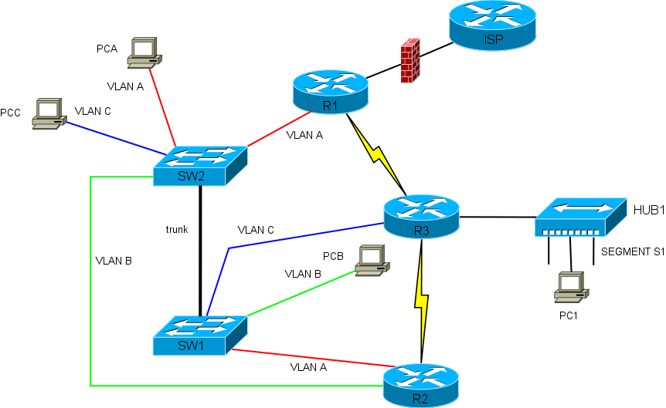

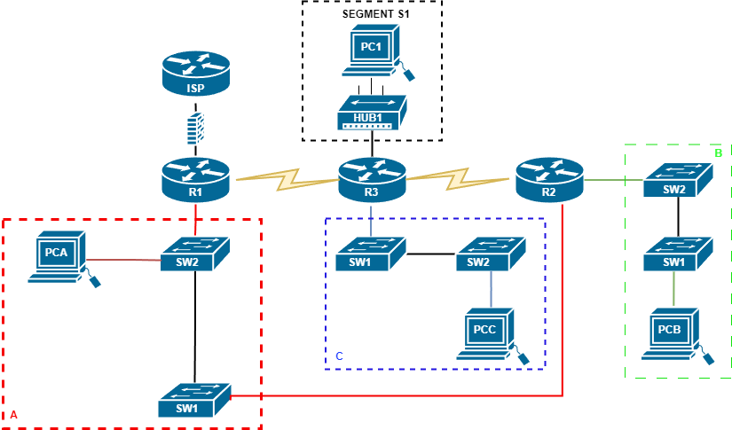Ekvivalentní L3 topologie

Adresní plán IPv4

Adresní plán privátních IPv4 adres

|  |  |  |  |
| --- | --- | --- | --- |
| **Segment sítě** | **Adresa podsítě/prefix** | **Adresa broadcastu** | **Adresní rozsah pro zařízení** |
| **VLAN C** | 10.75.76.160/27 | 10.75.76.192 | 10.75.76.161 - 10.75.76.191 |
| **ISP-R1** | 10.0.0.0/30 | 10.0.0.3 | 10.0.0.1 - 10.0.0.2 |

Adresní plán IPv4 veřejných adres

|  |  |  |  |  |  |
| --- | --- | --- | --- | --- | --- |
| **Segment** | **Síť/maska** | **První adresa** | **Poslední adresa** | **Broadcast** | **Počet Hostů** |
| **NAT pool** | 174.96.64.0/27 | 174.96.64.1 | 174.96.64.31 | 174.96.64.32 | 30 |
| **R1 – R3** | 174.96.64.32/30 | 174.96.64.33 | 174.96.64.34 | 174.96.64.35 | 2 |
| **R2 – R3** | 174.96.64.36/30 | 174.96.64.37 | 174.96.64.38 | 174.96.64.39 | 2 |
| **VLAN B** | 174.96.65.0/24 | 174.96.65.1 | 174.96.65.254 | 174.96.65.255 | 254 |
| **VLAN A** | 174.96.66.0/23 | 174.96.66.1 | 174.96.67.254 | 174.96.67.255 | 510 |
| **SEGMENT S1** | 174.96.68.0/23 | 174.96.68.1 | 174.96.69.254 | 174.96.69.244 | 510 |

IPv4 adresy rozhraní směrovačů

|  |  |
| --- | --- |
| **Segment sítě** | **Adresa podsítě** |
| **VLAN A – R1** | 174.96.66.1 |
| **VLAN A – R2** | 174.96.66.2 |
| **VLAN B – R2** | 174.96.65.1 |
| **VLAN C – R3** | 10.75.76.161 |
| **S1 – R3** | 174.96.68.1 |
| **R1 – R3** | 174.96.64.33 |
| **R3 – R2** | 174.96.64.37 |

IPv4 adresy stanic

|  |  |
| --- | --- |
| **Segment sítě** | **Adresa podsítě** |
| **PCA** | 174.96.67.254 |
| **PCB** | 174.96.65.254 |
| **PCC** | 10.75.76.191 |
| **PC1** | Automaticky přiděleno protokolem DHCP |

Adresní plán IPv6

|  |  |  |
| --- | --- | --- |
| **Segment sítě** | **Adresa podsítě/prefix** | **Adresní rozsah pro zařízení** |
| **NAT pool** | 2001:865c:a921:0000::/64 | 2001:865c:a921:0000::0001-2001:865c:a921:0000:ffff:ffff:ffff:ffff |
| **R1 – R3** | 2001:865c:a921:0001::/64 | 2001:865c:a921:0001::0001-2001:865c:a921:0000:ffff:ffff:ffff:ffff |
| **R2 – R3** | 2001:865c:a921:0002::/64 | 2001:865c:a921:0002::0001-2001:865c:a921:0000:ffff:ffff:ffff:ffff |
| **VLAN C** | 2001:865c:a921:0003::/64 | 2001:865c:a921:0003::0001-2001:865c:a921:0000:ffff:ffff:ffff:ffff |
| **VLAN B** | 2001:865c:a921:0004::/64 | 2001:865c:a921:0004::0001-2001:865c:a921:0000:ffff:ffff:ffff:ffff |
| **VLAN A** | 2001:865c:a921:0005::/64 | 2001:865c:a921:0005::0001-2001:865c:a921:0000:ffff:ffff:ffff:ffff |
| **SEGMENT S1** | 2001:865c:a921:0006::/64 | 2001:865c:a921:0006::0001-2001:865c:a921:0000:ffff:ffff:ffff:ffff |

IPv6 adresy rozhraní směrovačů

|  |  |
| --- | --- |
| **Segment sítě** | **Adresa podsítě/prefix** |
| **VLAN A – R1** | 2001:865c:a921:0005::0001 |
| **VLAN A – R2** | 2001:865c:a921:0005::0002 |
| **VLAN B – R2** | 2001:865c:a921:0004::0001 |
| **VLAN C – R3** | 2001:865c:a921:0003::0001 |
| **S1 – R3** | 2001:865c:a921:0006::0001 |
| **R1 – R3** | 2001:865c:a921:0001::0001 |
| **R3 – R2** | 2001:865c:a921:0002::0001 |

IPv4 adresy stanic

|  |  |
| --- | --- |
| **Segment sítě** | **Adresa podsítě/prefix** |
| **PCA** | 2001:865c:a921:0000:ffff:ffff:ffff:ffff |
| **PCB** | 2001:865c:a921:0000:ffff:ffff:ffff:ffff |
| **PCC** | 2001:865c:a921:0000:ffff:ffff:ffff:ffff |
| **PC1** | 2001:865c:a921:0000:ffff:ffff:ffff:ffff |